Principal’s Report May 16, 2022
Charter Goals
Goal #1 Show an annual increase in the percentage of graduates that are college and career ready as defined by the state.
Goal #2 Show an annual increase in student participation in additional rigorous coursework through positive relationships, community-building activities, family engagement, and student support.
Goal #3 Show an annual decrease in the achievement gap for historically underachieving populations (SPED, ELL, socio-economically disadvantaged, and minority students).

Academics/School Update of Events

Prom- The Grand Gala

This was our first normal Prom in three years. We had over 500 students attend (517+), which is the most ever. The students looked great and appeared to have a great time. Congratulations to Mrs. Quinn, the Prom Advisor, and her two assistants, Mrs. Barksdale and

Band Program

The South Carolina Band Directors Association formally announced that the JICHS band program has earned the Concert Achievement Award for this school year. The Concert Achievement Award is the highest achievement for band programs in South Carolina. To earn this award, you must have demonstrated a high level of proficiency in all areas of your program. Points were earned through your success in Region and

Last week was Teacher, which concluded with our 2nd annual Mental Health Fair. Thank you to Ms. Richardson, Mrs. David, Mrs. Gallgher, Ms. Singleton, and Mrs. Hamilton for all their hard work in making it a special week. Mrs. Ahrens and her crew (SPED Department, Scruggs, and Johnson) planned the Mental Health Fair.

2022 Teacher and Staff Appreciation Week

Senior Week

Below is a list of events the School Spirit Committee has planned.

Monday - Introducing the senior advice wall
Tuesday - Sunrise Breakfast in the student parking lot 7:15-8:15
Wednesday - Senior vs Faculty basketball game during CREW/XC State Champ Ring presentation
Thursday - Seniors will wear their decorated crowns as well as shirts for their college/career path
Friday - Senior Picnic

Senior exams begin on May 16, and Underclassman exams start on May 25. Teachers, please call the parents of any student that is in danger of failing, especially seniors. Proverb- an ounce of prevention is worth a pound of cure.

Teachers of seniors, please be on the outlook for the dreaded virus that is more contagious than the Omicron variant, Senioritis. We have test kits in the Clinic if you need some, or you can use the home test. The home test is very simple- are they senior, and is it spring? If you answered yes to both questions, your senior is positive for Senioritis. We will post the number of positive cases on our Senioritis Dashboard.

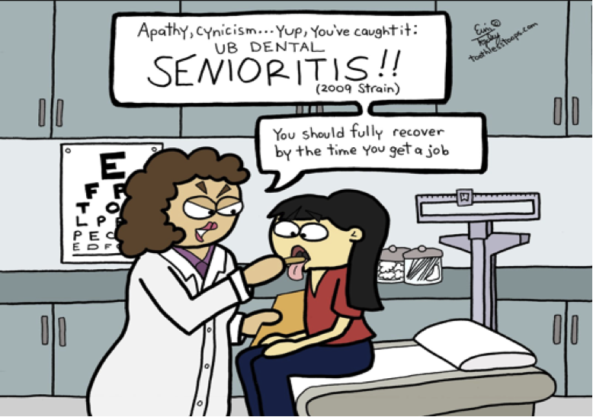

School Choice

 | JICHS In-house | CRMS | Buist | Haut Gap | Murray LaSaine | Orange Grove | 1st Choice  Apps | Totals
9th | 0 | 262 | 9 | 8 | 9 | 2 | 170 | 460
10th | 447 | N/A | N/A | N/A | N/A | N/A | 33 | 480
11th | 394 | N/A | N/A | N/A | N/A | N/A | 28 | 422
12th | 343 | N/A | N/A | N/A | N/A | N/A | 9 | 352
Totals |  |  |  |  |  |  | 240 | 1714

Enrollment Update
Grade | 9th | 10th | 11th | 12th | 9-12
6/11/2021 | 438 | 383 | 380 | 348 | 1549
8/11/2021 | 509 | 439 | 399 | 369 | 1716
9/17/2021 | 482 | 433 | 369 | 348 | 1632
10/15/2021 | 479 | 425 | 365 | 345 | 1614
11/08/2021 | 476 | 423 | 360 | 345 | 1604
12/10/2021 | 475 | 416 | 354 | 344 | 1589
1/29/2022 | 475 | 416 | 353 | 347 | 1591
2/25/2022 | 454 | 407 | 349 | 361 | 1571
3/15/2022 | 454 | 407 | 350 | 361 | 1572
4/18/2022 | 452 | 406 | 347 | 361 | 1566
5/16/2022

2021-22 Enrollment Projections

Enrollment As of  01/2022 | 9TH | 10TH | 11TH | 12TH
JICHS
CLARK | 0 | 0 | 0 | 0
DANIEL JENKINS | 1 | 0 | 0 | 0
EARLY COLLEGE | 4 | 12 | 6 | 9
PROJECT SEARCH | 0 | 0 | 0 | 1
TOTAL:

TOTAL | 1566
CLARK | 1
DANIEL JENKINS | 1
EARLY COLLEGE | 30
PROJECT SEARCH | 1
JICHS IN HOUSE TOTAL: | 1533

Capital Improvements and Building Maintenance

Furniture Project
We are starting to prepare for the furniture removal. Herald Office Solutions is supplying the tags and CCSD Operations is managing the removal of the furniture. The process starts on Tuesday, May 31, 2022.

CTE Construction and Gym Construction
The final OSF inspection did not go well. The fire alarm system was not set up correctly. Apparently, the two new buildings have different addresses (1002 & 1004). After three hours, the issue could not be resolved. The next inspection date is May 26, 2022, which is the earliest possible date the fire marshall can return. According to Mr. Clancy, that is more than enough to finish everything that is left to do. We will begin moving into the new buildings during the exam weeks.

Outdoor Classroom
The project is progressing. There were issues with the pillars, which needed to be addressed. The final inspection may occur on May 26, 2022, as well.

ROTC Drill Pad
We are working on getting quotes this summer. As soon as we have idea of the cost, I will seek board approval.

TMD
Clancy Wells is working with CCSD on converting the food lab into a TMD classroom. The design concept was approved last month. The project will be completed this summer.

Staff Restroom
We are waiting on a quote from a vendor. This is a two-week project. This should be completed this summer.

Baseball Pressbox and Batting Cage
Clancy Well have submitted the architectural drawings to the general contractor. We are waiting for quotes and timelines from them.

Field Turf Project
We have a general contractor and vendor selected for the project. The project will begin next fall and will take approximately 6-8 weeks.

JICHS Board of Directors Meeting Dates
2021-22 Board of Directors- The JICHS Board of Directors will meet in person at 5:30 pm in the Media Center on the dates listed below.
August 16, September 20, October 18, November 15, December 13, January 24, February 21, March 21, April 18, May 16, and June 13.

2021-22 Finance Committee- The JICHS Finance Committee will be in-person at 4:00 pm in the Main office Conference on the dates listed below.
August 9, September 13, October 11, November 8, December 6, January 10, February 14, March 14, April 4, May 9, June 13

Upcoming Events
5/2-5/6 Teacher Appreciation Week  5/12 CCSD Lead Meeting | 6/4 JICHS Graduation 11:30 am North Charleston Coliseum  6/27 Board Meeting

Executive Session (Personnel matters, Contract matters, Privacy of a student, and Legal Counsel)
Meeting Notes
Topic | Notes | Vote
Executive Session- Legal Letter, HR Protocols

