Principal’s Report December 13, 2022
Charter Goals
Goal #1 Show an annual increase in the percentage of graduates that are college and career ready as defined by the state.
Goal #2 Show an annual increase in student participation in additional rigorous coursework through positive relationships, community-building activities, family engagement, and student support.
Goal #3 Show an annual decrease in the achievement gap for historically underachieving populations (SPED, ELL, socio-economically disadvantaged, and minority students).

Academics/School Update of Events

Unified Program (SPED and General Education Students)

On November 18, the JICHS Unified Basketball Team took on the Unified Team from Bishop England. JI jumped out to a big first-half lead. Bishop England came roaring back in the second half to take the lead. With time expiring, JI hit a buzzer-beater to win the game 33-32. Congratulations to the players, coaches (students), and teachers on the win and for making this happen! (Schrimsher, Heflin)

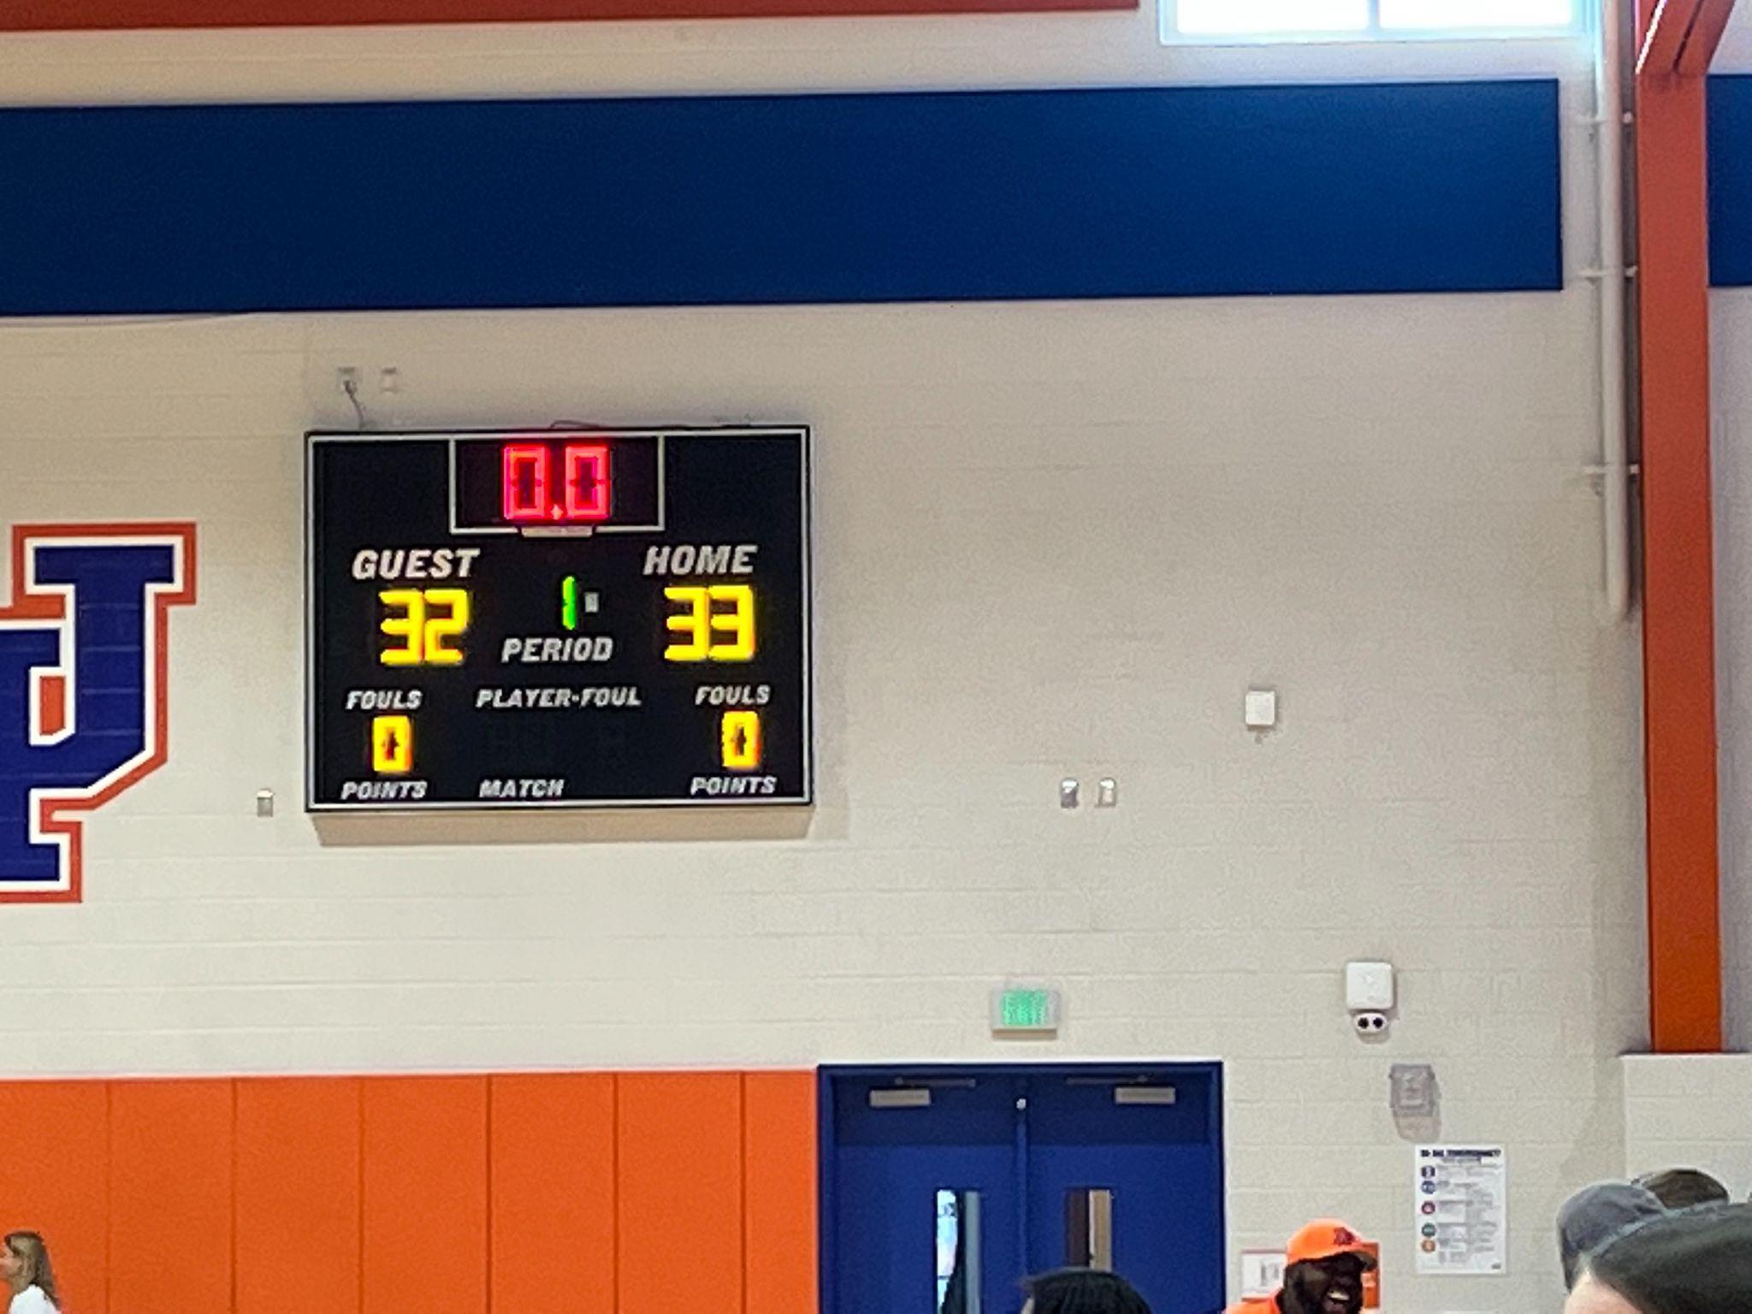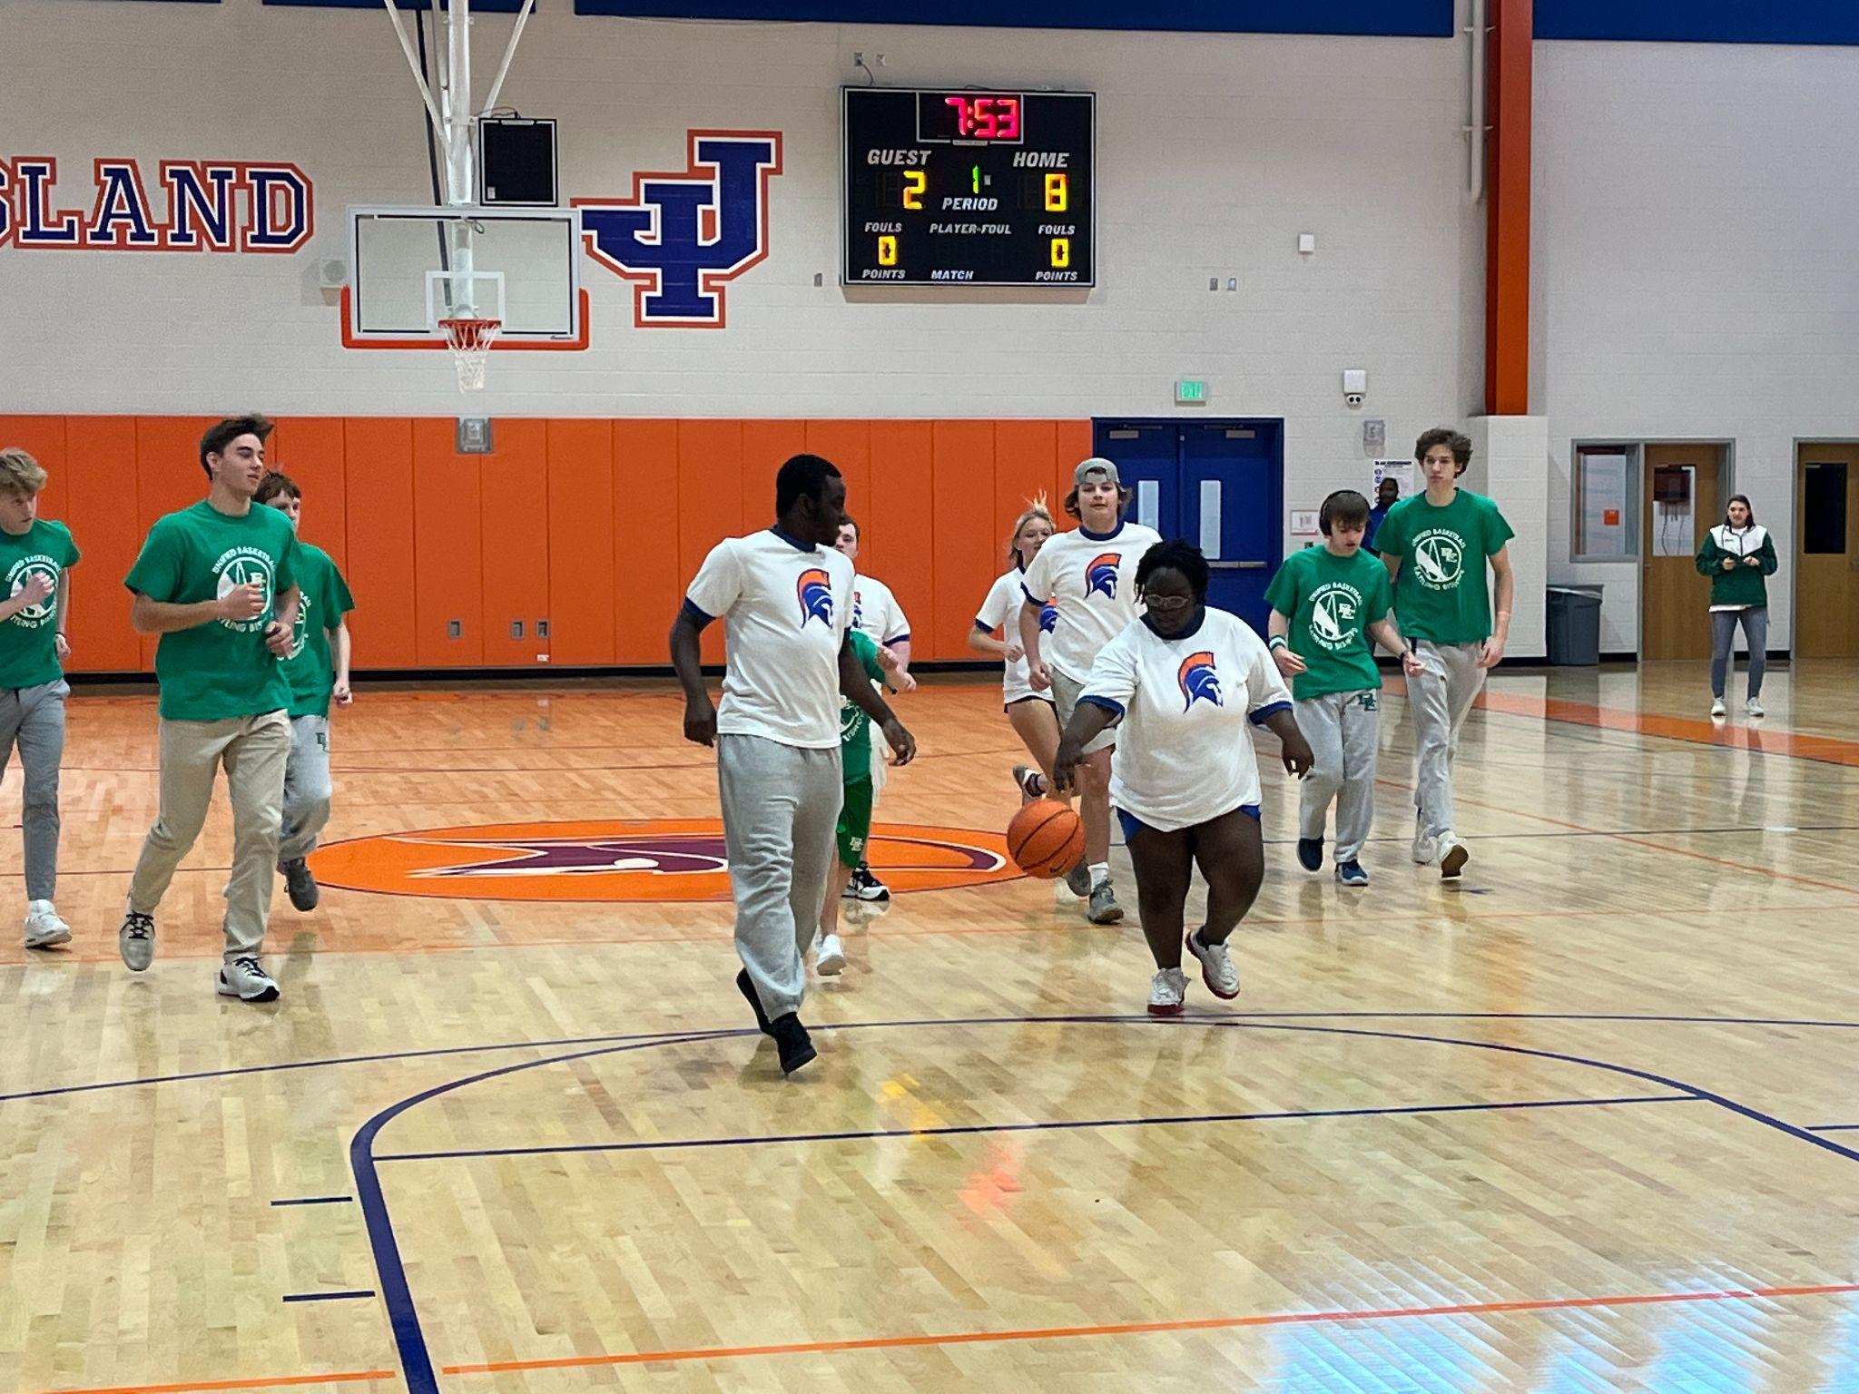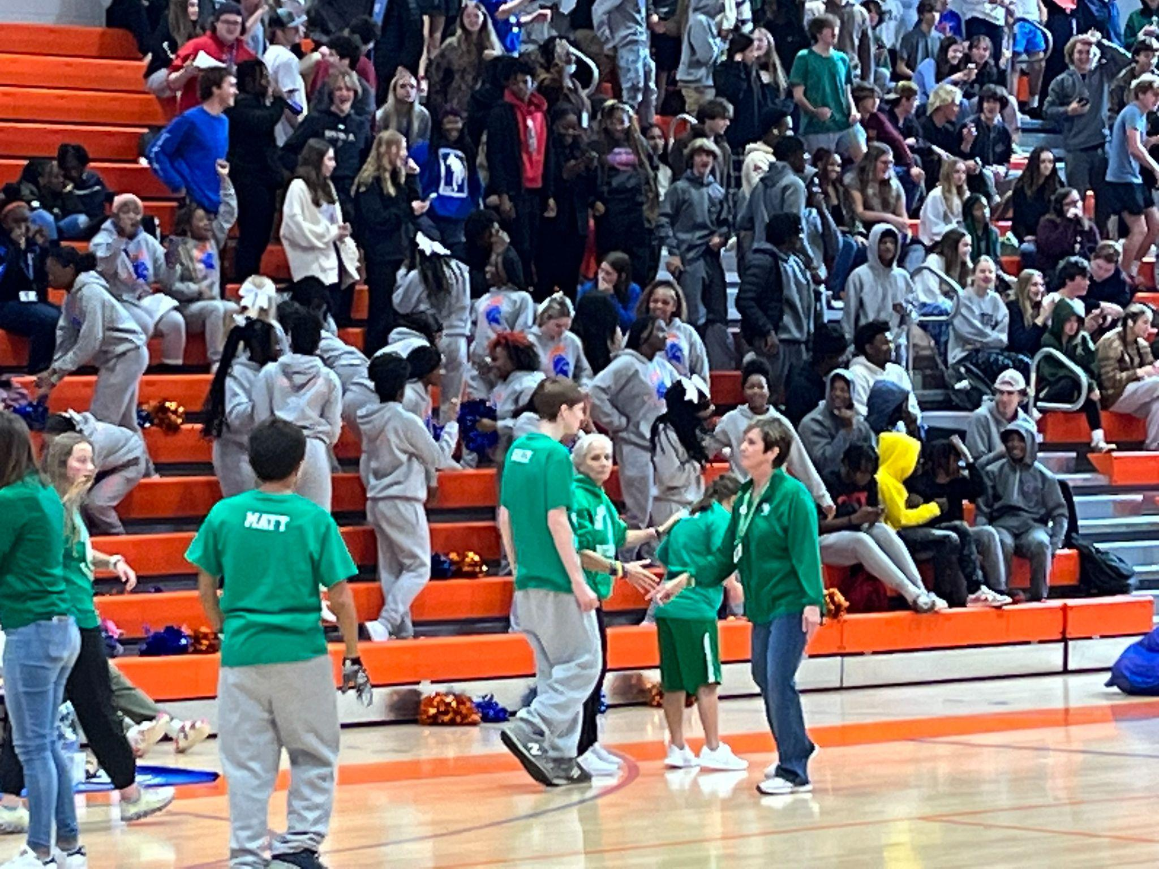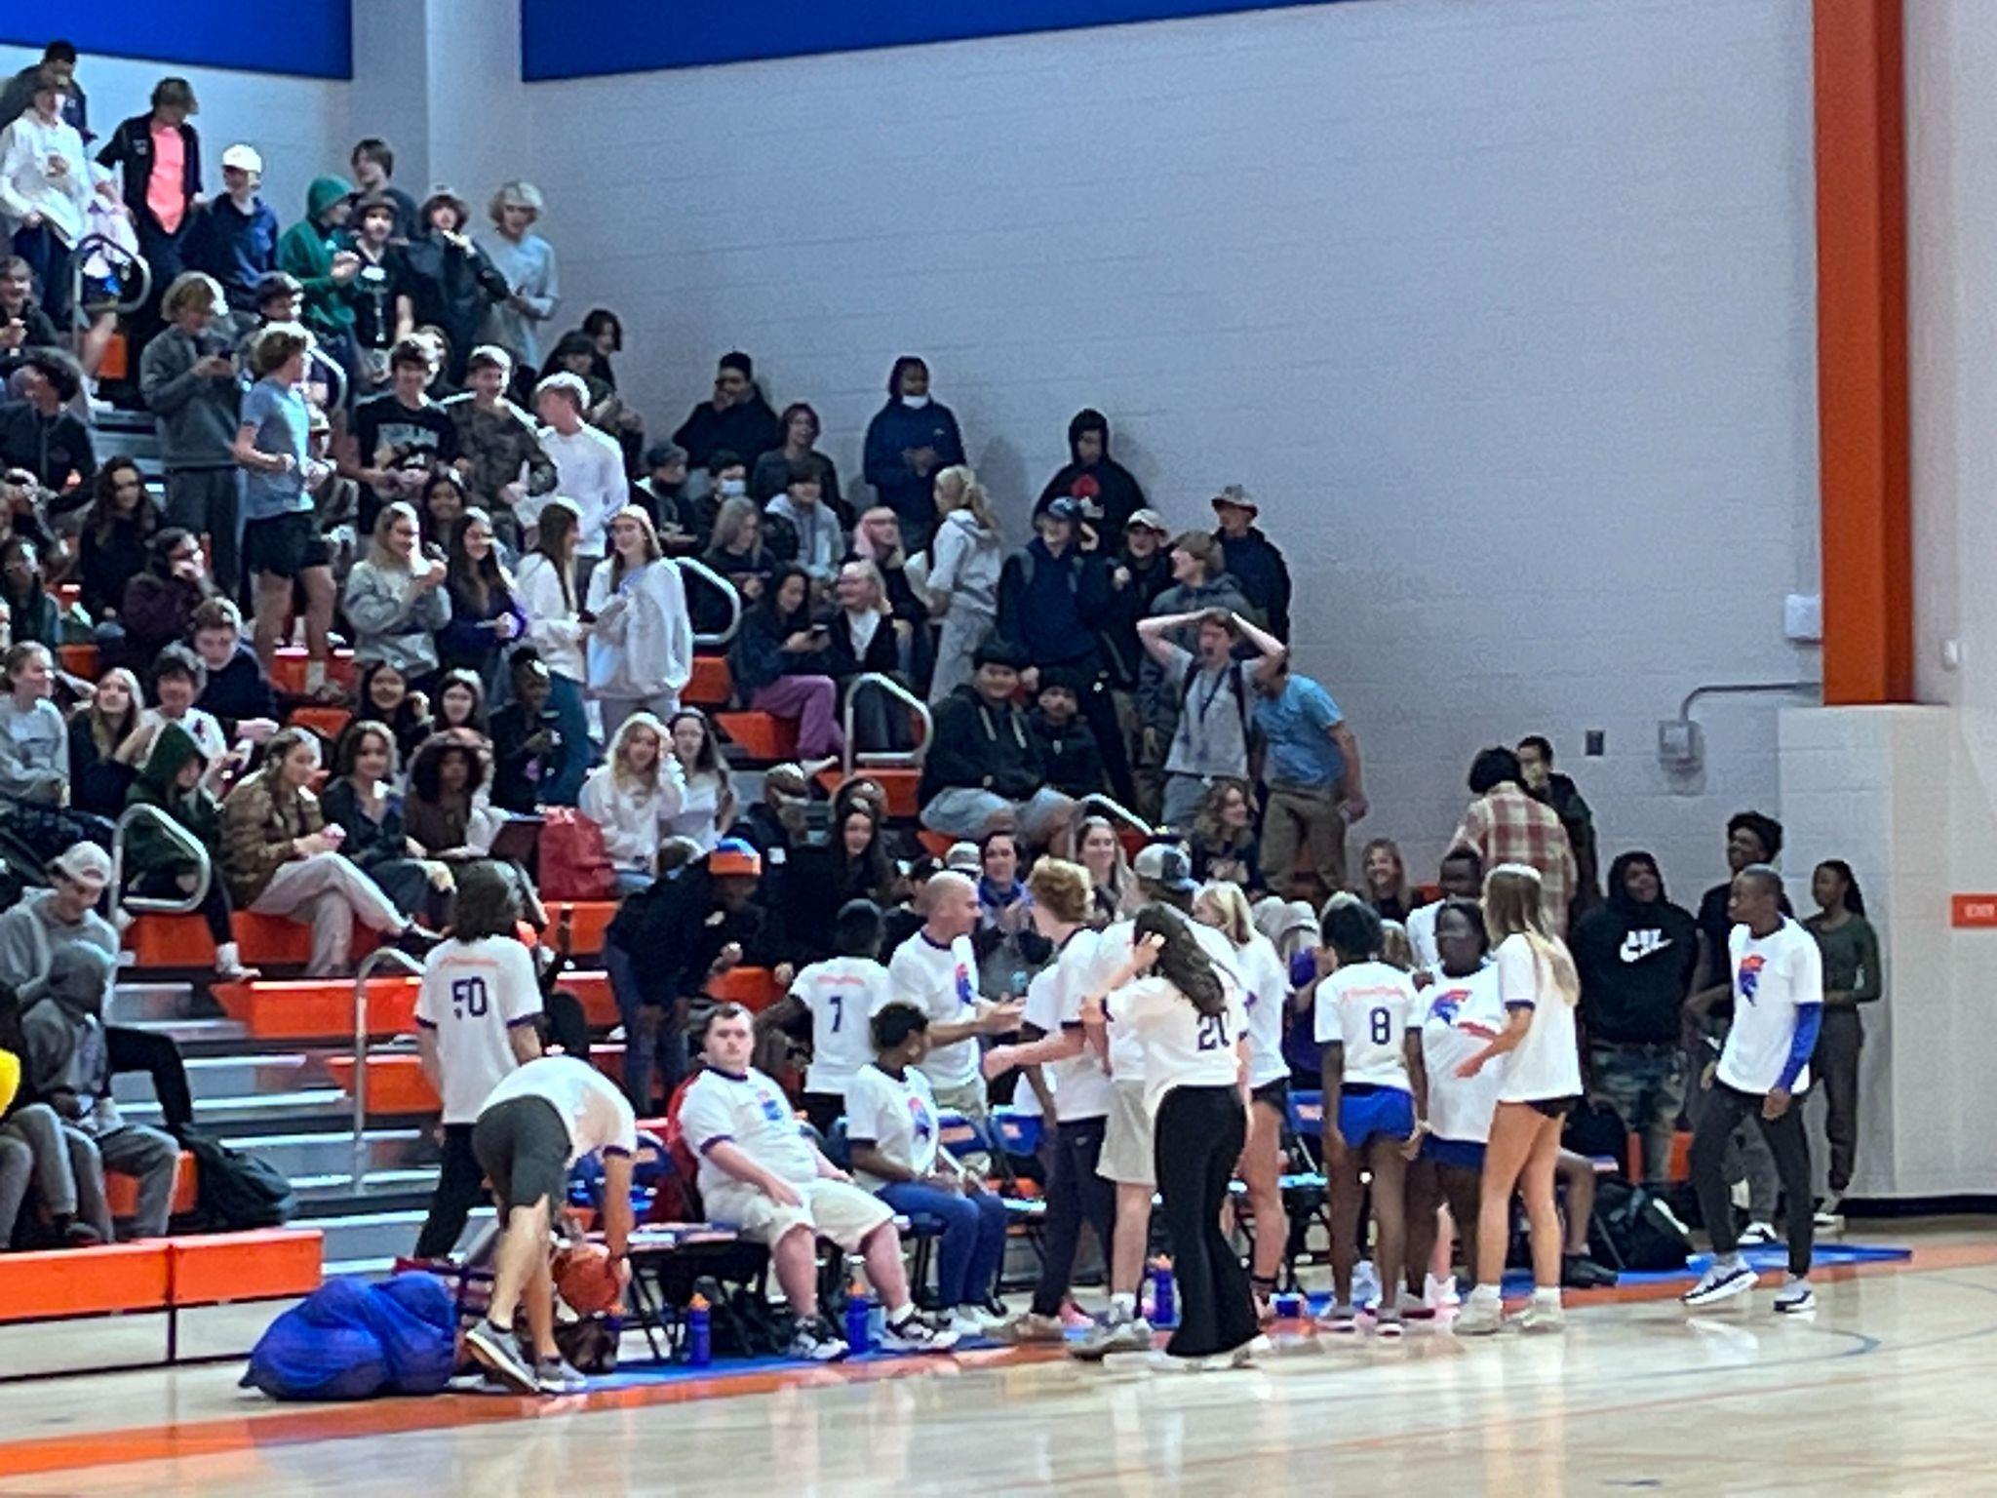

Distracted Driving Class

The Drive To Zero Distracted Driving Course will be facilitated in the Student Parking Lot by the SC Highway Patrol on Dec. 12th and 13th. Teachers were able to sign-up to take their entire class. The class demonstrates the effects of distracted and impaired driving.

December Professional Development (Sheli Ballard Instructional Coach)

- Panorama Date Review
- Authentic Writing
- Restorative Practices
- Inquiry-Based Learning
- ONLINE OPTION: Kirwan Institute Implicit Bias Modules
- ONLINE OPTION: Critical Practices for Anti-Bias Education -- Instruction
- ONLINE OPTION: Critical Practices for Anti-Bias Education -- Classroom Culture
- ONLINE OPTION: Critical Practices for Anti-Bias Education -- Classroom Culture

Walkthroughs

The admin team and Instructional Coaches continue to do weekly walkthroughs. To date, we have conducted over 230 walkthroughs. For the spring semester, teachers will be given several options for in-house monthly PD credit, including in-house PD sessions, organized learning walks, online modules, and through creating an action plan as part of Michele Johnson’s Equity in the Classroom graduate course in conjunction with CofC.

Erin’s Law

We are required by federal law to provide 45 minutes of instruction to every student every year on Erin’s Law. Erin’s Law is about educating and preventing child sexual abuse, which, unfortunately, is a problem in our community and worldwide. The Erin’s Law lessons will be completed during Trojan Check-in on December 7 & 14.

Semester 1

The holiday break is three days away! School resumes on January 4th, and exams officially begin on January 11, which only leaves five school days after the break.

Note: The addition of the Testing Coordinator Position/Instructional Coach has greatly benefited our school. Leslie McLaughlin has coordinated all the testing, including PSAT, SAT, ASVAB, EOCs, and G/T. Testing this spring will include ACT, SAT, and WIN for all three-year students, along with AP, IP, and EOCs. In addition, she provides outstanding PD for teachers each month.

2022-2023 JICHS Fall Exam Schedule

Program of Studies

Changes to the Program of Studies (POS) were December 2, 2022. The POS must be ready for course registration for the next school year, which begins in February. The Leadership Team is exploring more options for dual courses at JICHS for next year, especially in the CTE, English, and Math departments.

School Choice

CCSD has moved to a new platform for School Choice from School Mint. They provided regular training
throughout the year. The new platform is user-friendly and quite an initiative. Parents will find it easier to use than the previous platform. Below are the important dates for School Choice.

All applications are considered equal if they are entered within the application period listed below.
This tentative timeline provides the dates, deadlines, and events related to the application process for the 2023-2024 school year:
- January 24, 2023 - Online and paper application window opens.
- January 28, 2023 - Choice Fair
- February 24, 2023 - Online application submission and paper application drop-off window close at 5:00 pm.
- April 3, 2023 - Families will be notified by email of School Choice acceptance/decisions.
- April 20, 2023 - Offered seats must be accepted by 11:59 pm.
Please visit the Pre-K/Child Development web page for information on these programs. Please visit the Student Transfer web page for information on this application process.

CCSD School Choice Page

Enrollment Update

Grade | 9th | 10th | 11th | 12th | 9-12
6/11/2021 | 438 | 383 | 380 | 348 | 1549
6/3/2022 | 451 | 405 | 343 | 361 | 1560
8/8/2022 | 421 | 421 | 418 | 352 | 1612
9/16/2022 | 430 | 412 | 416 | 335 | 1593
10/17/2022 | 427 | 411 | 415 | 337 | 1590
11/14/2022 | 427 | 410 | 411 | 335 | 1583
12/13/2022 | 425 | 412 | 408 | 333 | 1578

TOTAL | 1578
CLARK | 2
DANIEL JENKINS | 0
EARLY COLLEGE | 19
PROJECT SEARCH | 0
JICHS IN HOUSE TOTAL: | 1557

Technology Update

The Technology Committee is focused on maintenance and repair of existing hardware. The one-to-one Chromebooks system is progressing well. Our new building server has been installed, working out issues common with hardware updates. We are evaluating WiFi access across the JI campus.

Capital Improvements and Building Maintenance

JICHS campus is classified as a special protection area (SPA). The city TRC review process requires resubmission. In short, the permitting process is more lengthy and complex. As a result, if/when this project moves forward, it will be next fall.
Given the Baseball Pressbox and Batting Cage project(s) scope, I have reached out to a firm for construction management services. This is how CCSD manages its various capital projects. The firm we may use does a lot of work with CCSD. We had significant issues with other capital projects, specifically the previous baseball project when a three-party GM company was not used.

22-23 JICHS Board Meeting Dates

Upcoming Events
1/11-1/13 Semester 1 Exam Week
1/16 MLK Day
1/18 First Day of Second Semester
1/9 Finance Committee Meeting 4:00 pm
1/17 Board Meeting 5:30 pm
6/3 JICHS Graduation 11:30 am North Charleston Coliseum

Executive Session (Personnel matters, Contract matters, Privacy of a student, and Legal Counsel)
Meeting Notes
Topic | Notes | Vote
Executive Session-

