Principal’s Report February 21, 2023
Charter Goals
Goal #1 Show an annual increase in the percentage of graduates that are college and career ready as defined by the state.
Goal #2 Show an annual increase in student participation in additional rigorous coursework through positive relationships, community-building activities, family engagement, and student support.
Goal #3 Show an annual decrease in the achievement gap for historically underachieving populations (SPED, ELL, socio-economically disadvantaged, and minority students).

Academics/School Update of Events
Spirit Week January 23-27
Thank you to Mrs. Hamilton and Ms. Bruns for planning the winter spirit week.
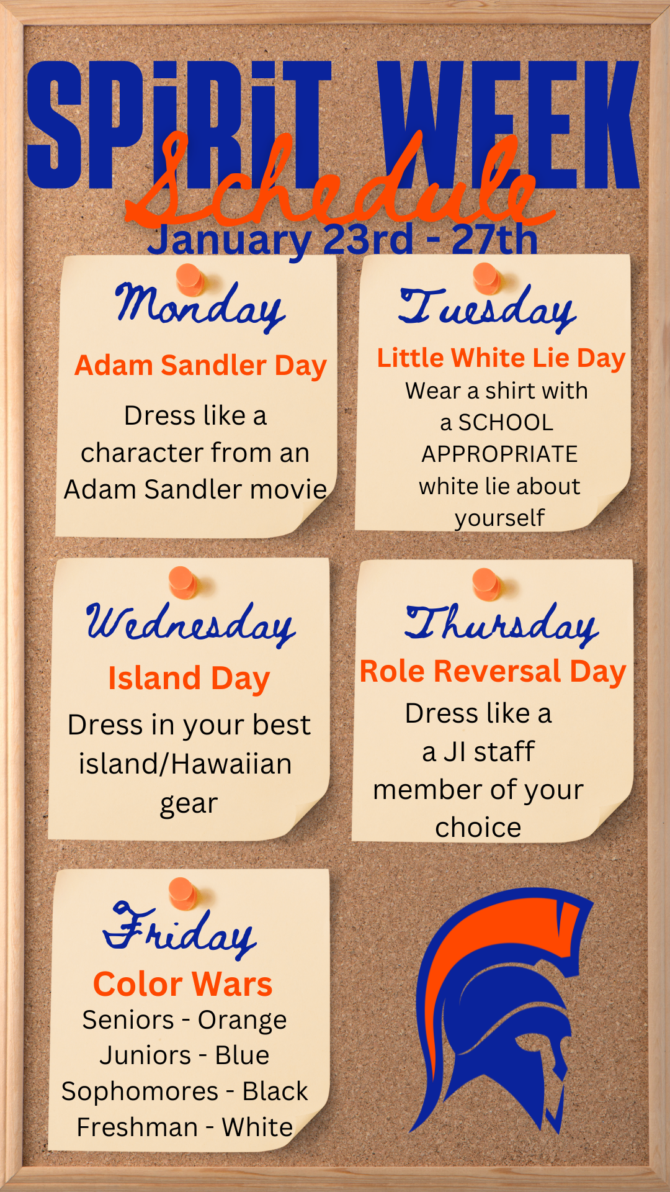

Teacher/Staff Attendance Incentive
55 staff members had perfect attendance this past month. 11 instructional staff had perfect attendance for the 2nd quarter.

Black History Month Calendar
Thank you to Michelle Johnson and her crew for planning all the events to celebrate Black History Month.

Black History Month Calendar of Events

Semester 2 Attendance Protocol
After reviewing attendance data and the Failure Due Absences Report, we recognized that we needed to be more consistent with our attendance protocol. There was definitely a hangover from Covid when attendance requirements were removed for a couple of years. First, we need daily attendance to be accurate, so we are running daily attendance audit reports. This will allow us to address issues immediately. To assist teachers with attendance notifications, we run attendance reports three times a quarter and provide email templates. The administrators will monitor the teachers in their department to ensure the proper notices are being sent to students and parents.

School Choice
All applications are considered equal if they are entered within the application period listed below.

This timeline provides the dates, deadlines, and events related to the application process for the 2023-2024 school year:

January 24, 2023 Online and paper application window opens at 5:00 pm.
January 28, 2023 Virtual Choice Fair.
February 24, 2023 Online application submission and paper application drop-off window closes at 5:00 pm.
April 3, 2023 Families will be notified by email of School Choice acceptance/decisions beginning at
5:00 pm. The decision notification process could take several hours to complete.
April 20, 2023 Offered seat must be accepted by 11:59 pm.

CCSD School Choice Page

Enrollment Update

Grade | 9th | 10th | 11th | 12th | 9-12
6/11/2021 | 438 | 383 | 380 | 348 | 1549
6/3/2022 | 451 | 405 | 343 | 361 | 1560
8/8/2022 | 421 | 421 | 418 | 352 | 1612
9/16/2022 | 430 | 412 | 416 | 335 | 1593
10/17/2022 | 427 | 411 | 415 | 337 | 1590
11/14/2022 | 427 | 410 | 411 | 335 | 1583
12/13/2022 | 425 | 412 | 408 | 333 | 1578
1/13/2023 | 423 | 410 | 405 | 332 | 1570
2/17/2023 | 401 | 423 | 390 | 352 | 1566

TOTAL | 1566
CLARK | 1
DANIEL JENKINS | 0
EARLY COLLEGE | 19
PROJECT SEARCH | 0
JICHS IN HOUSE TOTAL: | 1546

Human Resources

Current Openings

- American Sign Language Teacher 2023-24
- Guidance Director 2023-24
- Sports Medicine/Health Science Teacher- 2023-2024
- CTE Financial Literacy 2023-24

Assistant Principal Announcement
We are pleased to announce Melissa Kemp is the new assistant principal at JICHS starting March 13th. Many of us have worked with Melisssa over the years and know she is a top-notch educator. Mrs. Kemp has 15 years of experience in education, all with CCSD. Melissa started her career as Guidance Counselor/Career Development Coordinator at Lincoln Middle High School. She then moved to the CTE Department with CCSD as a CTE Data & Project Coordinator. Since 2016, she has been an AVID District Director. She helped multiple schools successfully implement AVID. Melissa was the CTE Interim Director from 2015-17. Since 2017 she has been the Career & Technology Education Program Coordinator. Her background in counseling, CTE, and AVID makes her an excellent fit for our school. Melissa will shadow a few hours weekly to prepare for the transition, so please welcome her.

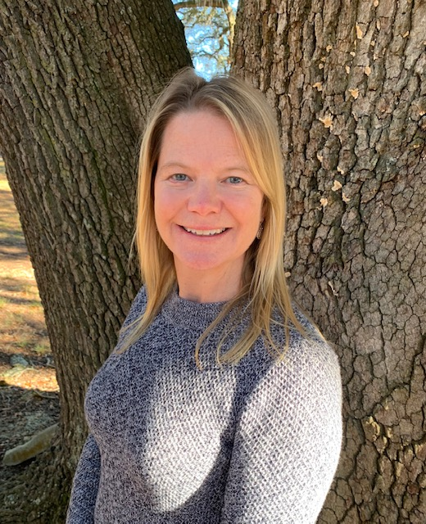

Auditing Services
Elliot-Davis has done our audit for over ten years. As a matter of best practice, we put our auditing services out to bid. Prestige drafted the RFP for us. We are expecting several bids for board consideration for the March board meeting. Elliot-Davis chose not to submit a proposal.

Custodial Services
Mr. Monette and I are finishing an RFP for custodial services for the next three school years. We will present the proposals later in the spring.

Capital Improvements Projects

Field Turf Project
Due to permitting issues, the field turf project is expected to break ground in mid-May. The project is expected to take eight weeks. The field should be ready for use in mid-July. Atlantic South is working with Sprint Turf and CCSD to coordinate the lighting project for the field.

Science Classrooms and Baseball Projects
We have contracted with Atlantic South to manage both of these projects. The next step is to coordinate the Clancy + Well’s schedule and help secure a surveyor to survey the site.

22-23 JICHS Board Meeting Dates

Executive Session (Personnel matters, Contract matters, Privacy of a student, and Legal Counsel)
Meeting Notes
Topic | Notes | Vote
Executive Session-

