Principal’s Report September 18, 2023
Charter Goals
Goal #1 Show an annual increase in the percentage of graduates that are college and career-ready as defined by the state.
Goal #2 Show an annual increase in student participation in additional rigorous coursework through positive relationships, community-building activities, family engagement, and student support.
Goal #3 Show an annual decrease in the achievement gap for historically underachieving populations (SPED, ELL, socio-economically disadvantaged, and minority students).

Academics/School Update of Events

JICHS Pillars of Practice
Our focus this year is on student engagement. We did a focus group activity with our staff to develop our non-negotiables, which we later named our Pillars of Practice (PIP). The goal was to decide on what we should expect in every classroom. Our instructional coach (Mrs. Ballard and McLaughlin) helped create the graphic below. We used the links as resources.
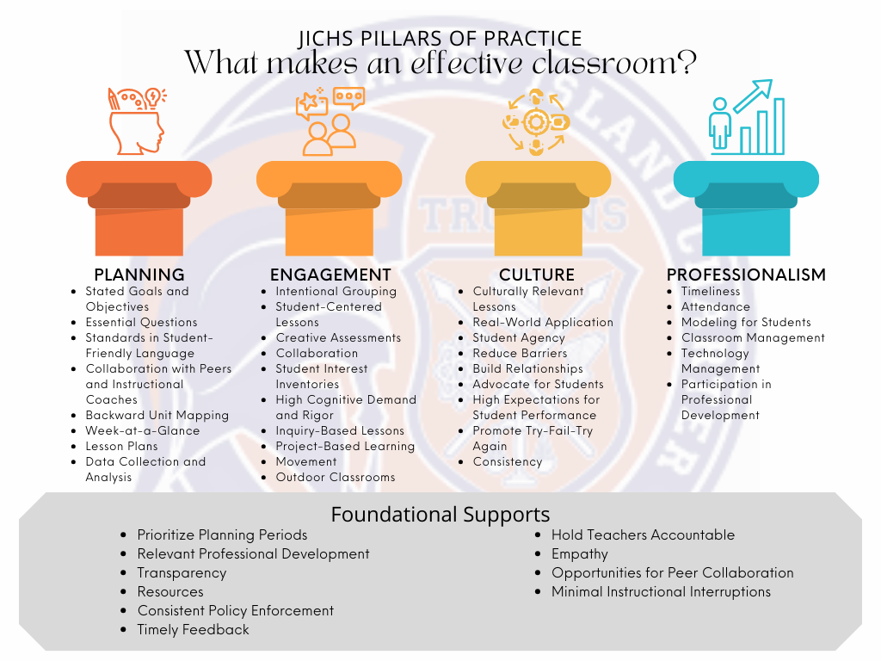
Levels of Engagement
PTR Rigor
4.0 Rubric

SchoolPass (SP)
SP finished the integration process on September 8th. SP had boots on the ground for two staff members on September 11th and 12th to help us get up and running. The integration process is still ongoing. The major issues are with WAHS. Based on the test we have run, it appears the automated attendance and pass system will work as planned. The visitor management system will work well in office locations but may not be fast enough for student arrival.

YONDR
The YONDR rollout has gone better than expected. The students have been generally accepting. I get the sense everyone realizes that phones, even the students, have been a problem for a while. It is not a big deal if you are doing what you are supposed to in class. We shared with them and their parents that everyone has a cell phone problem. Phone downtime (PDT) is healthy for everyone, especially when you are supposed to be working or learning.

Professional Development Semester
Our Instructional Coaches, Mrs. Ballard, and Mrs. Laughlin, developed the PD packages for our certified staff. Based on teacher interest, they customize the offerings. Staff meetings are scheduled during early release days for a total 45-min. These meetings will focus on our PIP and PD. The PD packages will occur during the planning periods versus after school.

JICHS Professional Development Packages

Enrollment Update

Grade | 9th | 10th | 11th | 12th | 9-12
6/13/2023 | 438 | 383 | 380 | 348 | 1549
8/15/2023 | 422 | 417 | 406 | 393 | 1603
9/15/2023
Note: 23 Program Students (Early College, Clark Academy, Daniel Jenkins).

Construction Update
The practice field project has not gone well. DCG held SprinTurf accountable all along the way, but they have not produced. DCG requested a detailed breakdown of incurred expenses, copies of invoices, an updated budget, the current status of turf field constructions, and an updated timeline for the remaining phases.

Executive Session (Personnel matters, Contract matters, Privacy of a student, and Legal Counsel)

Meeting Notes
Topic | Notes | Vote
Student A Appeal
Student B Appeal
Science Classroom Proposal
Athletic Project Proposal

