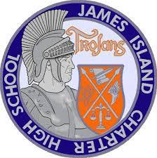
James Island Charter High School
Facilities/Maintenance Department
Marty Monette, Facilities Director
Maintenance Office 843-762-3788
Main Office 843-762-2754
Fax 843-762-8392

January 27th, 2020

1. 4 Gym boys locker room HVAC wall units have been replaced, 2 serving the boys P.E locker
room and 2 serving the boys basketball locker room.

2. DEHC inspected our stormwater retention ponds on Jan 9th, they passed.

3. Keating roofing put 150 linear feet of roof metal edging along the roof above the media center
to stop water intrusion into the building when it rains.

4. Damaged fencing around the retention pond at the student parking lot has
been repaired.

5. Annual campus-wide fire alarm systems test was performed 1/26/20, all passed.

6. JICHS Facilities Maint. has received and processed 101 work orders from Dec. 16th to the
present.

Marty Monette
Facilities Director, JICHS

